RELATIONSHIP OF DATA

1. **Scatter plot:**

To do a scatter plot in R between xData and yData, use:

*plot(xData, yData, col= “color Name”, main= “title of the plot”, xlab= “x name”, ylab= “y name”, pch=19)*

*Note, pch= 19 means you want to plot a filled circle. You can change this number for different shape (see figure 1).*

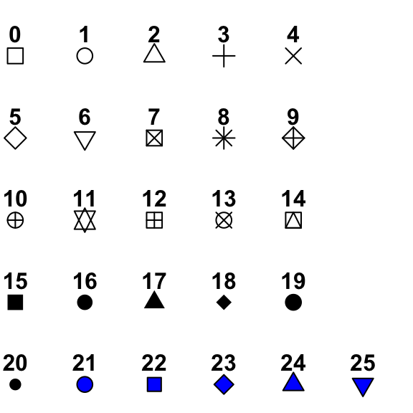

Figure 1: The different point symbols in R.

1. **Correlation and covariance:**

To find correlation between xData and yData, use:

*cor(xData, yData)*

To find corvariance between xData and yData, use:

*cov(xData, yData)*